ASP.NET Core 6 Web API Fundamentals

Swashbuckle is an impementation of open api

LaunchSettings.json

Sets up local machine for development.
This is not used in deployment.
There are 2 profiles here. Project (uses kestral web server ) and IIS Express.
You can edit this graphically by going into project settings.
Best to use Kestral.
When we start it we see a console app open with the details.

Swagger

Try it out and Execute

https://localhost:7126/swagger/index.html

https://localhost:7126/WeatherForecast

.NET CLI overview
https://learn.microsoft.com/en-us/dotnet/core/tools/

PS C:\dev\carleton\Carleton.api> dotnet

Usage: dotnet [options]
Usage: dotnet [path-to-application]

Options:
-h|--help Display help.
--info Display .NET information.
--list-sdks Display the installed SDKs.
--list-runtimes Display the installed runtimes.

path-to-application:
The path to an application .dll file to execute.

#PS
C:\dev\carleton\Carleton.api>dotnet run

Program.cs

Top level Statements Feature.
//its a web application
var builder = WebApplication.CreateBuilder(args);

//Add Services and configure them
builder.Services.AddControllers();
// Learn more about configuring Swagger/OpenAPI at https://aka.ms/aspnetcore/swashbuckle
builder.Services.AddEndpointsApiExplorer();
builder.Services.AddSwaggerGen();

//build application once services added
var app = builder.Build();

// Configure the HTTP request pipeline.
if (app.Environment.IsDevelopment())
{
app.UseSwagger();
app.UseSwaggerUI();
}

// Configure the HTTP request pipeline.
//if (app.Environment.IsDevelopment())
//{
// app.UseSwagger();
// app.UseSwaggerUI();
//}

//app.UseHttpsRedirection();

//app.UseAuthorization();

//app.MapControllers();

//app.Run();

app.Run(async (context) =>
{
await context.Response.WriteAsync("Hello world!");
});

app.Run();

Result:

https://localhost:7126/

Hello world!

All http requests result in the same outcome. “Hello world!”

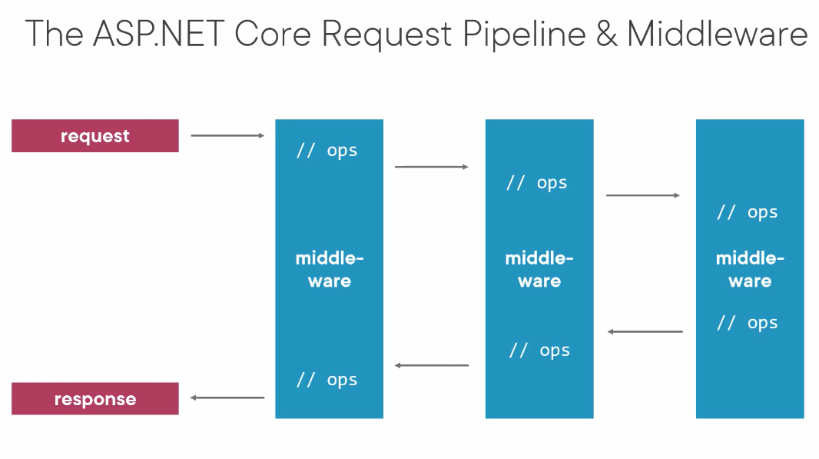

This is documentation in Swagger. It only runs in Development

//Configure the HTTP request pipeline.
if (app.Environment.IsDevelopment())
{
app.UseSwagger();
app.UseSwaggerUI();
}

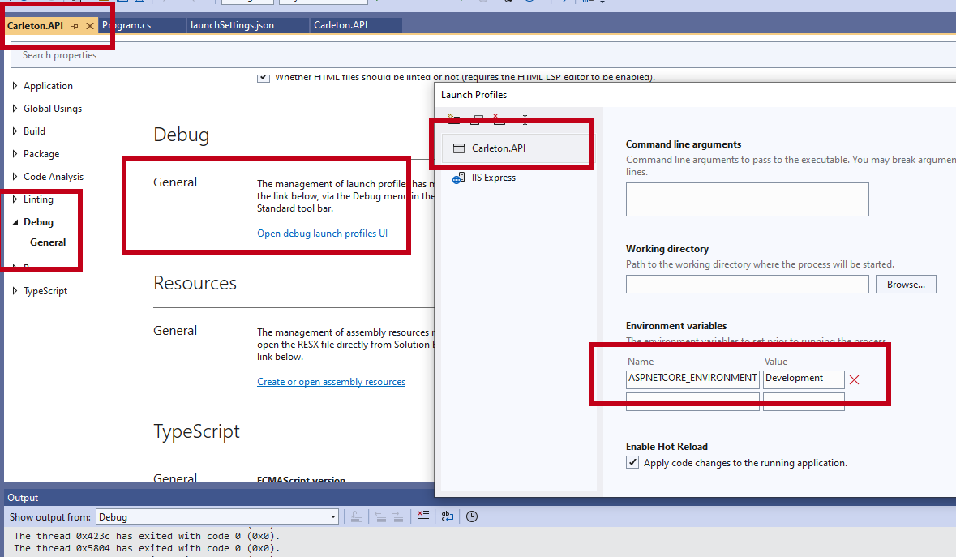
you can configure Development, Staging and Production

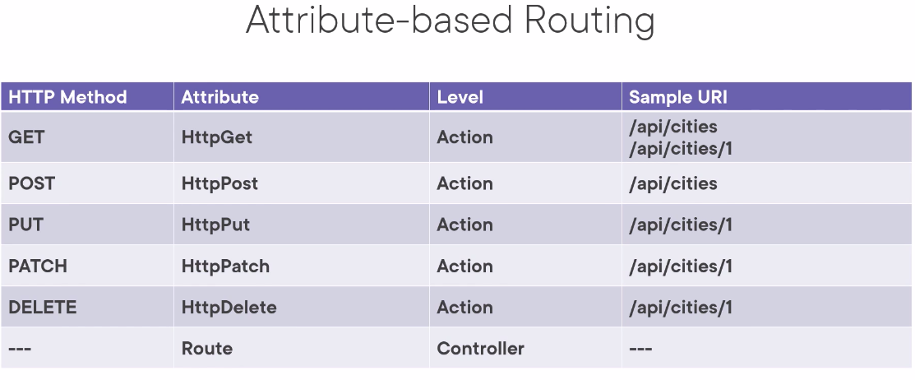
PostMan

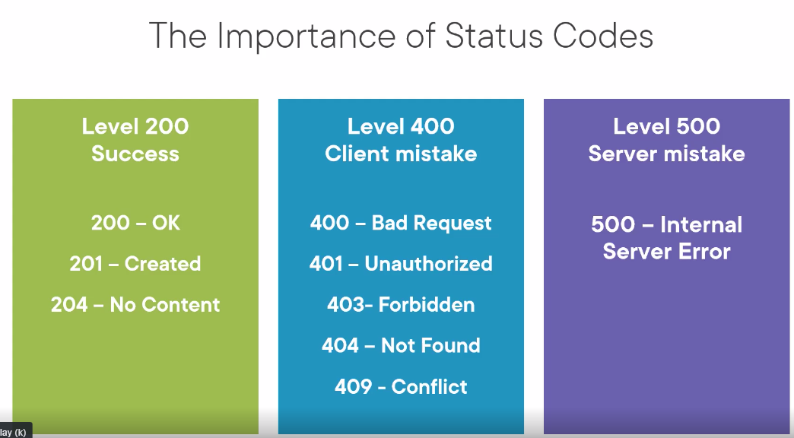

ActionResult vs JsonResult

We return an actionresult because it can contain status within it as well as the json itself.

This returns an ok result containing the json. ok is an implementation of IactionResult. Note that this can return an empty list.

[HttpGet]
public ActionResult<IEnumerable<CityDto>> GetCities()
{
return Ok(CitiesDataStore.Current.Cities);
}

If result not found we can return a notfound. Notfound is also an implementation of IActionResult

if (cityToReturn == null)
{
return NotFound();
}

